Membership Enrollment Form

Surname: _______________________First Name_________________Mr.____ Ms. ____ Dr. ____

Company: ______________________

Position /Title____________________________ Division /Section _____IRELAND SECTION___

Home Address: ____________________________________________________________________

Work Address: _____________________________________________________________________

Work Telephone _______________________ Mobile number _____________________

Work E-mail _______________________ Home E-mail _______________________

Birth Date (day/month/year) ____ ____ ____ Have you ever been an ISA member (yes/no) ______

Highest Qualification Earned: Certificate ____Diploma ____Degree ____Masters ____Doctorate____

If a Full Time Student: Name of College ___________________________Date of Graduation ______

Tick One of the following as your Primary Job Function
General or Corporate Management Plant Engineering /Maintenance Software Engineering
Engineering Management Measurement/Testing/Standards Systems Integration
Control Systems Engineering Technical/Engineering Support Operations
Product Design Engineering Research & Development Education/Training
System Design Engineering Plant Information Systems Marketing/Sales
Production Engineering Purchasing/Procurement Other: Describe

Main Industry Classification of your Employer: _________________________

Division Membership Options: effective from 1st Jan 2009 members are entitled to TWO free divisions

8 Industries & Sciences Departments 9 Automation & Technology Departments
Aerospace Mining & Metals Automatic Control Systems Analysis
Chemical & Petroleum Power Industry Process Measurement & Control Test Measurement
Construction & Design Pulp & Paper Robotics & Expert Systems Management
Food & Pharmaceutical Water & Wastewater Telemetry & Communications Safety
Computer Technology

Membership Fees Options - € / $ exchange reviewed on three monthly basis

ISA membership for 1 year: €77 / $100 2 years €143 / $186 3 years €204 / $265

3 Year Student Member: €15 Additional division membership fee each: €8 / $10

Total Amount Due: €________

Payment Options
(A) Cheque___ (B) Dollar Draft___ (C) Online___ (D) Credit Card: Type of Card __________

Credit Card Account Number: ______________________________ Expire Date : ______________

Signature: ______________________________ Date : _____________________

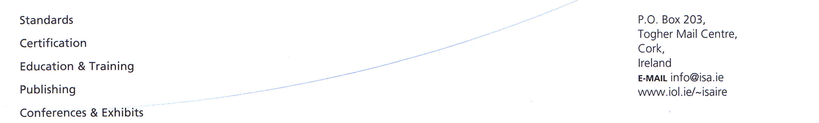
Return to Membership Chairman Billy Walsh: b.walsh@ucc.ie or Fax to 021-4276398

